-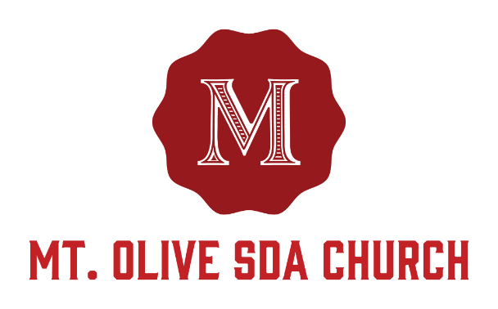
Congratulations on your decision to dedicate your child to the Lord! Our church is eager to assist you in this important matter. Baby Dedication ceremonies are usually at the request of the family.

Due to the spiritual nature of the comments rendered during the Baby Dedication Ceremony, it is helpful for the Pastor to understand the marital and living situation of both parents. Therefore, an appointment with Pastor Lawrence Hamilton is essential. Such a meeting is also a time to discuss the meaning of this event, and how a baby dedication is different than an infant baptism.

Once your application is received in the office, the office administrator will call you to schedule an appointment with you. After a face-to-face meeting with the Pastor, he will confirm the date of the dedication service with the office administrator.

During the morning worship service, Pastor Hamilton will invite parents, godparents, friends, family and the child being dedicated to come to the front of the sanctuary to begin the Baby Dedication Ceremony. At the conclusion of the ceremony, a Certificate of Dedication will be presented to the parents.

IMPORTANT: Turn the attached request form into the church office ONE MONTH prior to the requested date. You may also email the attached form to: mtolivechurchassist@gmail.com.

