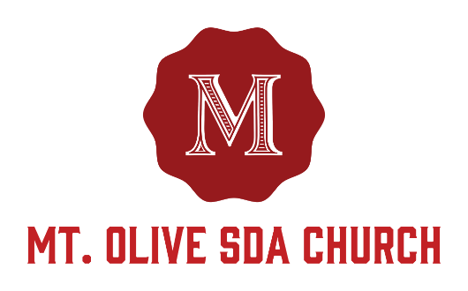

Baby Dedication Request Form

If you would like to have a baby/child dedicated at Mount Olive SDA Church, please submit one form per child. Please be advised that your requested Baby Dedication date is not confirmed until you have received confirmation from Drake Barber. PLEASE PRINT!
Child’s Information
Child’s full name: ___________________________________ Gender: Male Female
Date of Birth: _______/_______/_______ Hospital where child was born: _____________________
Month Day Year
Requested Month of Dedication: ________ Second Option: _________ Requested date: ________

PARENTS INFORMATION
Mother’s Name: ______________________________ Father’s name: ______________________________

Full Address: ________________________________________________________________________
(Please include City, State and Zip)
Home Phone Number: (___) ________ Email Contact: _________________________________

Mother’s Work Number: (___) ____________Father’s Work Number: (___) _______________

Are one or both parents born again Christians? Yes No Still considering Unsure what this means
Are one or both parents members of Mount Olive SDA Church?  Yes,  No

Due to the spiritual nature of the questions asked during the Baby Dedication Ceremony, it is helpful for the Pastor to understand the marital and living situation of both parents. Which of the following best describes the parents’ marital and living situation?
 Married and living together  Never married and living together
 Never married and not living together  Divorced  Separated
 Other (please explain: ______________________________________________________________)

GODPARENTS INFORMATION
Godmother’s Name: ____________________________ Godfather’s Name: _______________________

Who will participate in the Baby Dedication Ceremony?
Both parents Mother only Father only Godparent(s) Family Members & Friends (Please check all that apply)

________________________________ __________________________________
(Mother’s Signature) (Father’s Signature)

Mount Olive Staff only below this line
-------------------------------------------------------------------------------------------------------------------------------

_____________________________ _______________________________
(Pastor’s Signature) (Church Administrators Signature)

_____________________________ _______________________________
(First Elder’s Signature) (Church Clerks Signature)

