Women’s Ministry – Ladies, we hope that you are enjoying the study and many blessings received during this 40 Days of Prayer and Devotion. We are planning a lunch and discussion tentatively scheduled for September 23rd so mark your calendars! May God richly bless each of you.

South Atlantic Conference Mental Health Conference - August 25th – 27th at the camp ground! Registration has been extended to August 15th at www.adventsource.org! Call 404-792-0535, ext. 111 to reserve housing by August 20th. For additional information, contact Rosemary Graham at 404-792-0535, ext. 503.

Special Announcement - If you or a loved one is suffering from an addiction to drugs, alcohol, and other mind-altering substances, then please come and receive Spiritual guidance on how to regain your freedom to overcome the habit. We meet at 7 PM, every 1st and 3rd Friday of each month in the chapel of the Berean SDA Church at 291 H.E. Holmes Dr. Atlanta, GA 30318. All are welcome to attend!

Sermon Notes
__________________________________________________________________________________________________________________________________________________________________________________________________________________________________________________________

Meetings & Reminders

Sabbath:
- Early Morning Prayer Service at 8:45am
- Trailblazers Pathfinder every 1st Sabbath in Fellowship Hall
- AYS Program every 2nd, 3rd, and 4th Sabbath

Sunday:
- Trailblazers Pathfinder every 3rd Sunday in Fellowship Hall
- Adventurers Meetings
Every 1st and 3rd Sundays, 10am-1pm.

Tuesday/Wednesday:
- Bulletin submissions due by 8pm.
Email Sister Kelli Duncan at mtolivechurchassist@gmail.com
- Email Newsletter (News from The Mount)
Submit to info@mtolivesda.com by Wednesday, 12 noon

Wednesday:
- Mid-Week Prayer Service from 7 - 8 pm.

Pastoral Staff

Lawrence Hamilton , Pastor 770 597-5981
Gerald Helton, First Elder 404 502-6481
Lance Willis, Head Deacon 718 664-5631
Annie Jennings, Head Deaconess 770 969-2369
Kelli Duncan, Church Clerk 404 694-3113
Jerome Gallon, General Sabbath School Supt. 404 573-3411
John Clark, Community Services Director 404 798-0287
Jerome Gallon, Personal Min. Dir. 404 573-3411
Jason Harris, Treasurer 404 723-2999
Drake Barber, Church Admin 470-774-0068

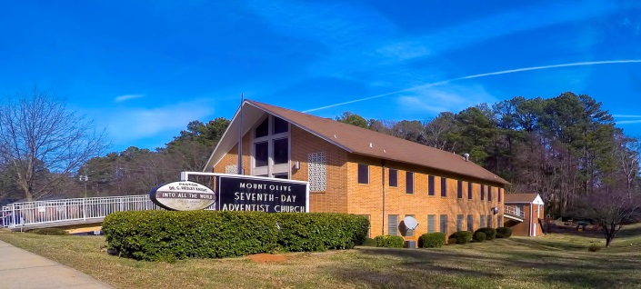
Mt. Olive
SDA Church

Pastor Lawrence Hamilton

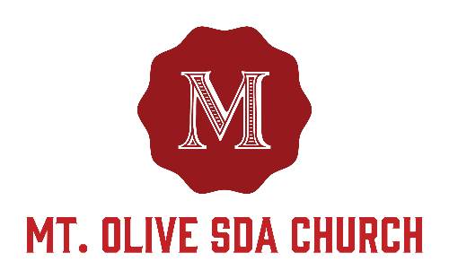

3366 Mt. Olive Road
East Point, GA 30344
404-228-9182
www.mtolivesda.com

August 19, 2017

Our Mission:

Proclaim the Good News

Lead Others to Christ

Unite Others with His Church

Prepare for Christ’s Return

General Information

On Duty Today
Church Clerk: Sister Kelli Duncan
Music/Worship Coordinator: Sim Stevenson
Prayer Request Coordinator: Sister Lydia Cole,
770-774-1434

Online Giving - Return your tithes and offerings online using the Adventist Giving Program, which can be accessed via our website: http://mtolivesda.com/. We would like to thank each of you who have responded by doing your part in helping us to fulfill our mission to God.

Financial Information:
Budget for July 2017 . . . . . . . . . . . . . $17,658.73
Amount received . . . . . . . . . . . . . . . . . $2,043.61
Outstanding Balance . . . . . . . . . . . . . . $15,615.12

Let us continue to work together to reach our goals to support our church and our ministries.

Sunset Today 8:19 pm
Sunset Next Friday 8:11 pm

Sick and Shut In

Please remember our sick and shut in members in prayer. Give them a call to let them know you care.

Sister Hazel Jackson 404-474-2337
Sister Louise Dunson 404-524-2720
Sister Willie Pearl Williams 770-808-6921
Sister Patricia Hilliary 404-766-1173
Brother Arthur P. Meadows 404-762-5958
Sister Kathleen Albert 770-695-3927
Ann Williams

Sabbath School
9:15 am
Superintendent: Jerome Gallon
Opening Song
Scripture & Prayer
Welcome
Mission Emphasis
Teacher’s Prayer
Lesson Study
Closing Remarks & Prayer

Personal Ministries / Departmental Announcements
11:20 – 11:30 am

Divine Worship Service
11:30 am
Introit Praise Team

Scripture Reading Elder Gerald Helton

Opening Prayer Elder Gerald Helton

Welcome Elder Gerald Helton

Children’s Story Bro. Melvin Cameron

Hymn of Praise Brother Calvin Manley

Intercessory Prayer Elder Leroy Thomas

Tithes & Offerings Elder Leroy Thomas

Praise and Worship Praise Team

Sermon Pastor Lawrence Hamilton

Closing Pastor Lawrence Hamilton

Announcements

AYS Department – Join the AYS department for “The social media” discussion – tomorrow evening at 6pm. See you there!

Education - “And all your children shall be taught of the Lord.” The registration process for SDA institutions is still underway. Please take advantage of this wonderful leap of faith that God is providing on behalf of our children. Whether online, or in person, let’s move forward in the registration of our children for Christian education. Please contact Elder Ron Jackson immediately with the names of all children that will be attending an SDA school at 404-422-6560. Thank you for your speedy response, Elder Ron Jackson.

Family Life - September is Family Life month and the Mt. Olive’s Family Life department is pleased to bring you programs and activities with the whole family in mind! Programs are designed to encourage greater connectivity within each family unit, individual spiritual growth and team-building fun for all ages. Check the church website and weekly bulletin announcements for updated Family Ministries events. If you are interested in assisting with the various Family Life events please contact Linda Seal at 561-722-3902.

