Adventurer Club - The trip to the Tellus Museum in Cartersville, GA is scheduled for tomorrow 8/27.
The parent/guardian for each family will have to attend as well for each child attending. Departure is at 9AM and Return is 4PM.

GAAA/BCJA – SAVE THE DATE! October 7-8, 2017 is BCJA/GAAA Alumni Weekend. Our speaker for Divine Service is Dr. Ivan Williams, alumnus of BJA. Also, it is time to elect alumni officers which will take place on Sunday at 11:00 am in the school's cafeteria. Brunch will be provided. For more information, please contact the school or Lauren Hastings at lauren.hastings@hotmail.com.

Special Announcement – The Peachtree City SDA Church, located at 4957 Hwy 34 E in Sharpsburg, will host Creation Health classes beginning on Tuesday, September 12, and will continue each Tuesday evening for eight weeks. Dinner will be served at 6:30 p.m. with the class from 7 - 8:30 p.m. The cost of the class is $25/individual and $35/couple. Free childcare will be provided for children ages 10 and under. Attendees will have the opportunity to discover information about whole body health and learn practical steps to healthier, happier living. To register, go to ptcsda.com.

Community Announcement - Bridges of Success Academy presents its 1st Annual Fundraiser on August 27th at 3:00pm. The concert features Gospel Recording Artists VIRTUE! The concert also features Dr. Cynthia Winthrop, an independent artist. This Fundraiser's goal is to help special needs students and support holistic family education programs. The concert will be at the Mable House Barnes Amphitheater in Mableton, GA. Tickets can be purchased at Ticketmaster.

Meetings & Reminders

Sabbath:
- Early Morning Prayer Service at 8:45am
- Trailblazers Pathfinder every 1st Sabbath in Fellowship Hall
- AYS Program every 2nd, 3rd, and 4th Sabbath

Sunday:
- Trailblazers Pathfinder every 3rd Sunday in Fellowship Hall
- Adventurers Meetings
Every 1st and 3rd Sundays, 10am-1pm.

Tuesday/Wednesday:
- Bulletin submissions due by 8pm.
Email Sister Kelli Duncan at mtolivechurchassist@gmail.com
- Email Newsletter (News from The Mount)
Submit to info@mtolivesda.com by Wednesday, 12 noon

Wednesday:
- Mid-Week Prayer Service from 7 - 8 pm.

Pastoral Staff

Lawrence Hamilton , Pastor 770 597-5981
Gerald Helton, First Elder 404 502-6481
Lance Willis, Head Deacon 718 664-5631
Annie Jennings, Head Deaconess 770 969-2369
Kelli Duncan, Church Clerk 404 694-3113
Jerome Gallon, General Sabbath School Supt. 404 573-3411
John Clark, Community Services Director 404 798-0287
Jerome Gallon, Personal Min. Dir. 404 573-3411
Jason Harris, Treasurer 404 723-2999
Drake Barber, Church Admin 470-774-0068

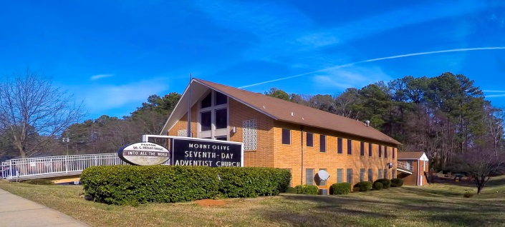
Mt. Olive
SDA Church

Pastor Lawrence Hamilton

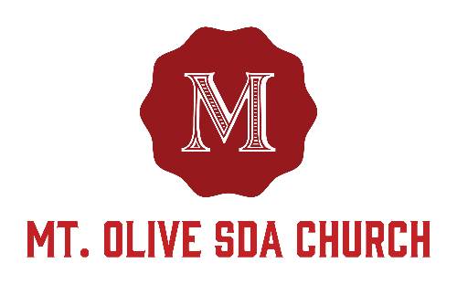

3366 Mt. Olive Road
East Point, GA 30344
404-228-9182
www.mtolivesda.com

August 26, 2017

Our Mission:

Proclaim the Good News

Lead Others to Christ

Unite Others with His Church

Prepare for Christ’s Return

General Information

On Duty Today
Church Clerk: Sister Kelli Duncan
Music/Worship Coordinator: Sim Stevenson
Prayer Request Coordinator: Sister Lydia Cole,
770-774-1434

Online Giving - Return your tithes and offerings online using the Adventist Giving Program, which can be accessed via our website: http://mtolivesda.com/. We would like to thank each of you who have responded by doing your part in helping us to fulfill our mission to God.

Financial Information:
Budget for August 2017 . . . . . . . . . . . $17,658.73
Amount received . . . . . . . . . . . . . . . . . $8,264.62
Outstanding Balance . . . . . . . . . . . . . . $9,394.11

Let us continue to work together to reach our goals to support our church and our ministries.

Sunset Today 8:10 pm
Sunset Next Friday 8:02 pm

Sick and Shut In

Please remember our sick and shut in members in prayer. Give them a call to let them know you care.

Sister Hazel Jackson 404-474-2337
Sister Louise Dunson 404-524-2720
Sister Willie Pearl Williams 770-808-6921
Sister Patricia Hilliary 404-766-1173
Brother Arthur P. Meadows 404-762-5958
Sister Kathleen Albert 770-695-3927
Ann Williams

Sabbath School
9:15 am
Superintendent: Jerome Gallon
Opening Song
Scripture & Prayer
Welcome
Mission Emphasis
Teacher’s Prayer
Lesson Study
Closing Remarks & Prayer

Personal Ministries / Departmental Announcements
11:20 – 11:30 am

Divine Worship Service
11:30 am
Introit Praise Team

Scripture Reading Elder Ronald Jackson, Sr.

Opening Prayer Elder Ronald Jackson, Sr.

Welcome Elder Ronald Jackson, Sr.

Children’s Story Sister Alexander

Hymn of Praise Brother Calvin Manley

Intercessory Prayer Elder Fernon Woodbine

Tithes & Offerings Elder Fernon Woodbine

Praise and Worship Praise Team

Sermon Pastor Lawrence Hamilton

Closing Pastor Lawrence Hamilton

Announcements
AYS Department – Join the AYS department for another fun and spirit-filled program tonight at 6pm. See you there!

Family Life - Family Life – September is Family Life month and the Mt. Olive Family Life Department is pleased to bring you the following AY programs and activities with the entire family in mind:

- September 9: AYS: Health and Temperance Day
- September 16: AYS: Laws of Dating – Dramatic, but timely, skits and discussion topics you don’t want to miss
- September 16: Evening Activity: Pathfinder/Family Life joint activity – Pathfinder Intake and social @ Campbelltown YMCA
- September 23: AYS: The Mission Field – Embodying
- September 23: Evening Activity: Group Dating Event - location TBD

Come enjoy programs and activities that encourage greater connectivity, spiritual growth, family bonding and fun for ages. If you are interested in assisting with the various Family Life events, please contact Linda Seal at 404-629-1055.
Condolences to the Harris Family - Brittany Harris ' youngest daughter, Scarlet, passed overnight. Please keep her and the entire family of Sister Helene Harris in your prayers. They may be reached at 404-344-8182.

Women’s Ministry – Ladies, mark your calendars! We are planning a lunch and discussion of tentatively scheduled for September 23rd. May God richly bless each of you.

