South Atlantic Conference Mental Health Conference – “I Am Mental Health: Do You See Me?” coming soon – August 25th – 27th at the camp ground! Go online to register with Advent Source – www.adventsource.org. Early bird special deadline is July 5th and registration ends August 8th! Call the office – 404-792-0535, ext. 111 and reserve housing (separate cost) with Marlene Edwards.

For additional information, contact Rosemary Graham at 404-792-0535, ext. 503

Special Prayer – Please keep the family of Linda and Paul Seal in prayer as they deal with the loss of a loved one.

Special Announcement - If you or a loved one is suffering from an addiction to drugs, alcohol, and other mind-altering substances, then please come and receive Spiritual guidance on how to regain your freedom to overcome the habit. We meet at 7 PM, every 1st and 3rd Friday of each month in the chapel of the Berean SDA Church. 291 H.E. Holmes Dr. Atlanta, GA 30318 404 799 - 7288. All are welcome to attend!

Meetings & Reminders

Sabbath:
- Early Morning Prayer Service at 8:45am
- Trailblazers Pathfinder every 1st Sabbath in Fellowship Hall

Sunday:
- Trailblazers Pathfinder every 3rd Sunday in Fellowship Hall
- Adventurers Meetings
Every 1st and 3rd Sundays, 10am-1pm.

Tuesday/Wednesday:
- Bulletin submissions due by 8pm.
Email Sister Kelli Duncan at mtolivechurchassist@gmail.com
- Email Newsletter (News from The Mount)
Submit to info@mtolivesda.com by Wednesday, 12 noon

Wednesday:
- Mid-Week Prayer Service from 7 - 8 pm.

Pastoral Staff

Lawrence Hamilton , Pastor 770 597-5981
Gerald Helton, First Elder 404 502-6481
Lance Willis, Head Deacon 718 664-5631
Annie Jennings, Head Deaconess 770 969-2369
Lunie Stephens, Church Clerk 678 408-0967
Jerome Gallon, General Sabbath School Supt. 404 573-3411
John Clark, Community Services Director 404 798-0287
Jerome Gallon, Personal Min. Dir. 404 573-3411
Jason Harris, Treasurer 404 723-2999
Drake Barber, Church Admin 470-774-0068

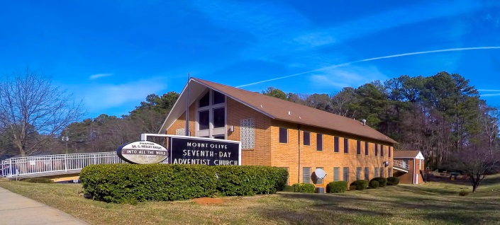
Mt. Olive
SDA Church

Pastor Lawrence Hamilton

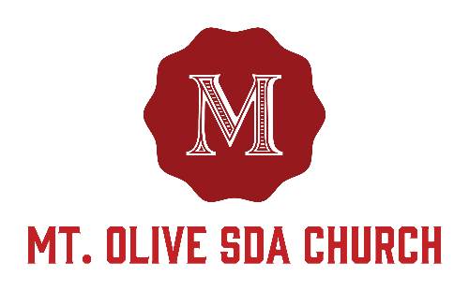

3366 Mt. Olive Road
East Point, GA 30344
404-228-9182
www.mtolivesda.com

June 24, 2017

Our Mission:

Proclaim the Good News

Lead Others to Christ

Unite Others with His Church

Prepare for Christ’s Return

Welcome Visitors

The Mt. Olive Church family is so delighted to have you in our midst today. May you receive the blessings of the Holy Spirit. Please come again to worship with us.

Let’s be a church which studies God’s Word!

General Information

On Duty Today
Church Clerk: Sister Lunie Stephens
Music/Worship Coordinator: Sim Stevenson
Prayer Request Coordinator: Sister Lydia Cole,
770-774-1434

Online Giving - Return your tithes and offerings online using the Adventist Giving Program, which can be accessed via our website: http://mtolivesda.com/

Sunset Today 8:51 pm
Sunset Next Friday 8:52 pm

Sick and Shut In

Please remember our sick and shut in members in prayer. Give them a call to let them know you care.

Sister Hazel Jackson 404-474-2337
Sister Louise Dunson 404-524-2720
Sister Willie Pearl Williams 770-808-6921
Sister Patricia Hilliary 404-766-1173
Brother Arthur P. Meadows 404-762-5958
Sister Kathleen Albert 770-695-3927
Ann Williams

Sabbath School
9:15 am
Superintendent: Jerome Gallon
Opening Song
Scripture & Prayer
Welcome
Mission Emphasis
Teacher’s Prayer
Lesson Study
Closing Remarks & Prayer

Personal Ministries / Departmental Announcements
11:20 – 11:30 am

Divine Worship Service
11:30 am
Introit Praise Team

Scripture Reading Elder Gerald Helton

Opening Prayer Elder Gerald Helton

Welcome Elder Gerald Helton

Children’s Story Elder Leroy Thomas

Hymn of Praise Praise Team

Intercessory Prayer Elder Leroy Thomas

Tithes & Offerings Elder Leroy Thomas

Praise and Worship Praise Team

Sermon Elder Gerald Helton

Closing Elder Gerald Helton

Announcements
1. AYS Department – Join the AYS department this evening for another spirit filled program.

2. Pathfinders – WASHINGTON DC TRIP:
Please keep us in your prayers as we journey to Washington D.C. tomorrow. We have 44 passengers ready to go! Remember, if you have registered to attend, please report to the church by 8:30 pm.

3. Family Life - We all have a place in Mt. Olive's Family Life Ministry!!!
Family Ministries focuses on the family as a whole and on each individual that comprises the unit. It focuses on strengthening the relationships between the individuals in the family -- the relationship that connects husband and wife in marriage, parent and child in a unique parent-child bond, family to family in the community of faith and in the wider society. Each individual is essential to the effective functioning of the family.

If you're interested in serving our church family, please contact Brother Paul Seal or Sister Linda Seal at 404-629-1055. FYI, we need youth involvement...teens, young adults and the young at heart.

Women’s Ministry - 40 Days of Prayer and Devotions in Preparation for the Second Coming
Ladies, we hope that you are enjoying the study and many blessings received during this 40 Days of Prayer and Devotion. If you have not begun your lesson as of yet, there is still time. A culmination event /group discussion is forth coming. In the meantime, please continue to pray and ask God for the outpouring of the Holy Spirit. May God richly bless each of you.

