Special Thanks - Sis. Bettie Jones extends a heartfelt thank you to all who prayed, sent cards, called, and visited during her recovery and bereavement.

GAAA/BCJA – SAVE THE DATE! October 7-8, 2017 is BCJA/GAAA Alumni Weekend. Our speaker for Divine Service is Dr. Ivan Williams, alumnus of BJA. Also, it is time to elect alumni officers which will take place on Sunday at 11:00 am in the school's cafeteria. Brunch will be provided. For more information, please contact the school or Lauren Hastings at lauren.hastings@hotmail.com.

Bereavement – Continue to keep the Dunson family in prayer.

Meetings & Reminders

Sabbath:
- Early Morning Prayer Service at 8:45am
- Trailblazers Pathfinder every 1st Sabbath in Fellowship Hall
- AYS Program every 2nd, 3rd, and 4th Sabbath

Sunday:
- Trailblazers Pathfinder every 3rd Sunday in Fellowship Hall
- Adventurers Meetings
Every 1st and 3rd Sundays, 10am-1pm.

Tuesday/Wednesday:
- Bulletin submissions due by 8pm.
Email Sister Kelli Duncan at mtolivechurchassist@gmail.com
- Email Newsletter (News from The Mount)
Submit to info@mtolivesda.com by Wednesday, 12 noon

Wednesday:
- Mid-Week Prayer Service from 7 - 8 pm.

Pastoral Staff

Lawrence Hamilton , Pastor 770 597-5981
Gerald Helton, First Elder 404 502-6481
Lance Willis, Head Deacon 718 664-5631
Annie Jennings, Head Deaconess 770 969-2369
Kelli Duncan, Church Clerk 404 694-3113
Jerome Gallon, General Sabbath School Supt. 404 573-3411
John Clark, Community Services Director 404 798-0287
Jerome Gallon, Personal Min. Dir. 404 573-3411
Jason Harris, Treasurer 404 723-2999
Drake Barber, Church Admin 470-774-0068

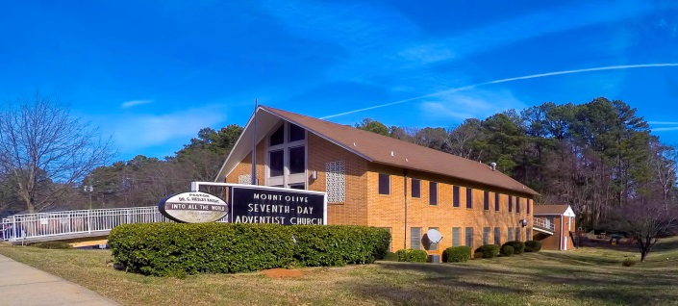
Mt. Olive
SDA Church

Pastor Lawrence Hamilton

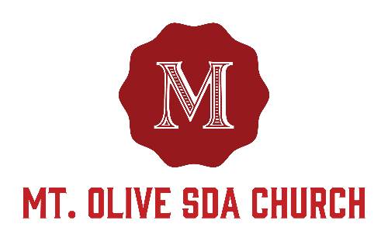

3366 Mt. Olive Road
East Point, GA 30344
404-228-9182
www.mtolivesda.com

September 23, 2017

Our Mission:

Proclaim the Good News

Lead Others to Christ

Unite Others with His Church

Prepare for Christ’s Return

General Information

On Duty Today
Church Clerk: Sister Yvonne Smith
Music/Worship Coordinator: Sim Stevenson
Prayer Request Coordinator: Sister Lydia Cole,
770-774-1434

Online Giving - Return your tithes and offerings online using the Adventist Giving Program, which can be accessed via our website: http://mtolivesda.com/. We would like to thank each of you who have responded by doing your part in helping us to fulfill our mission to God.

Financial Information:
Budget for Sept 2017 . . . . . . . . . . . $17,658.73
Amount received . . . . . . . . . . . . . . . . . $12,941.46
Outstanding Balance . . . . . . . . . . . . . . $4,717.27

Let us continue to work together to reach our goals to support our church and our ministries.

Sunset Today 7:32 pm
Sunset Next Friday 7:24 pm

Sick and Shut In

Please remember our sick and shut in members in prayer. Give them a call to let them know you care.

Sister Hazel Jackson 404-474-2337
Sister Willie Pearl Williams 770-808-6921
Sister Patricia Hilliary 404-766-1173
Brother Arthur P. Meadows 404-762-5958
Sister Kathleen Albert 770-695-3927
Ann Williams

Sabbath School
9:15 am
Superintendent: Jerome Gallon
Opening Song
Scripture & Prayer
Welcome
Mission Emphasis
Teacher’s Prayer
Lesson Study
Closing Remarks & Prayer

Personal Ministries / Departmental Announcements
11:20 – 11:30 am

Divine Worship Service
11:30 am
Introit Praise Team

Scripture Reading Elder Gerald Helton

Opening Prayer Elder Gerald Helton

Welcome Elder Gerald Helton

Children’s Story Elder Leroy Thomas

Hymn of Praise Brother Calvin Manley

Intercessory Prayer Elder Ron Jackson

Tithes & Offerings Elder Ron Jackson

Praise and Worship Praise Team

Sermon Pastor Lawrence Hamilton

Closing Pastor Lawrence Hamilton

Announcements
Family Life - September is Family Life month! Come out to each AYS program this month and join Mt. Olive’s Family Life Department in celebrating our families.

- September 23: Mission Adventure – Ever think about going on a mission trip? If so, come out and hear from those who have taken the plunge and learn about mission opportunities.

Come enjoy programs and activities that encourage greater connectivity, spiritual growth, family bonding and fun for ages. If you are interested in assisting with the various Family Life events, please contact Linda Seal at: 404-629-1055.

